EM108 Examination Report

Mock Exam

STUDENT ID: 15410402
STUDENT NAME: Michael Lenehan
Programme: CE1

I hereby declare that the attached submission is all my own work, that it has not previously been submitted for assessment, and that I have not knowingly allowed it to be used by another student. I understand that deceiving or attempting to deceive examiners by passing off the work of another as one's own is not permitted. I also understand that using another's student’s work or knowingly allowing another student to use my work is against the University regulations and that doing so will result in loss of marks and possible disciplinary proceedings.
Signed: Michael Lenehan | Date: 14/04/2016
Note: Coursework examiners are entitled to reject any coursework which does not have a signed copy of this form attached or are submitted late.

Exercise: The aim of this exercise is to write a program which can read from a file all the information in relation to a house, i.e. the house ID, owners name, waste weight, water usage, and surface area. Using this information, it computes the payable tax attributed to the house, and through a user menu, this can be printed to the screen or to a file.

Plan Include Standard C Libraries
Define the “house” structure
Declare the list of functions
Write function to print a user menu and take user inputs to execute other functions
Write function to read values from the data file
Write function that computes the tax which is attributable to each house
Write function to print results to an output file
Write function that prints results to an on screen table.
Write the main function to give opening message, and to call all other functions.

Development
Development began with the introduction of the standard C libraries: stdio.h, stdlib.h, and string.h. From here the structure “house” was defined. The read_records function was then written, and added to the list of functions. This function contains a while loop, which reads through the data until the end of the file has been reached. It scans for the different variables contained in the house structure, and stores them in the array. Next, the compute_tax function was written and added to the function list. This function uses an “if, else” statement to compute the tax payable by each house, due to the values of that houses waste, area and water variables. The beginning of the main function was written, including the variables of “norecs” and “i”, which are used in loops throughout the program, and the program compiled to ensure there were no errors in these functions. From here, the write_records, and print_results functions were written, and again added to the list of functions. The program was again compiled and this time tested to ensure it was working correctly. The print_menu function was then written, added to the list of functions, and called in the main function. From the menu function, all other functions are called according to the users input.

Testing
Testing was performed to ensure all aspects of the program were working correctly.
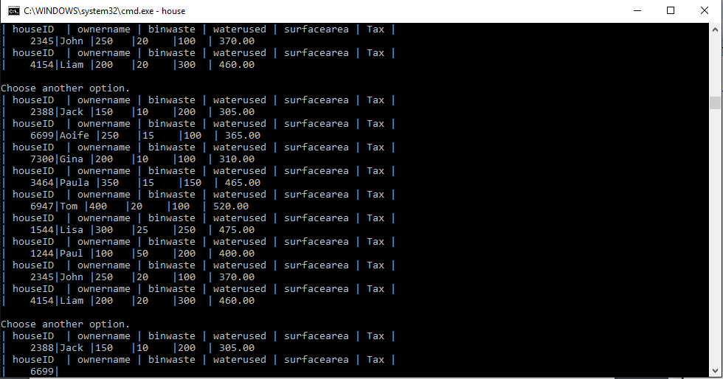
Program incorrectly printing multiple times to both screen and file due to misplaced while loop.

Program correctly printing table
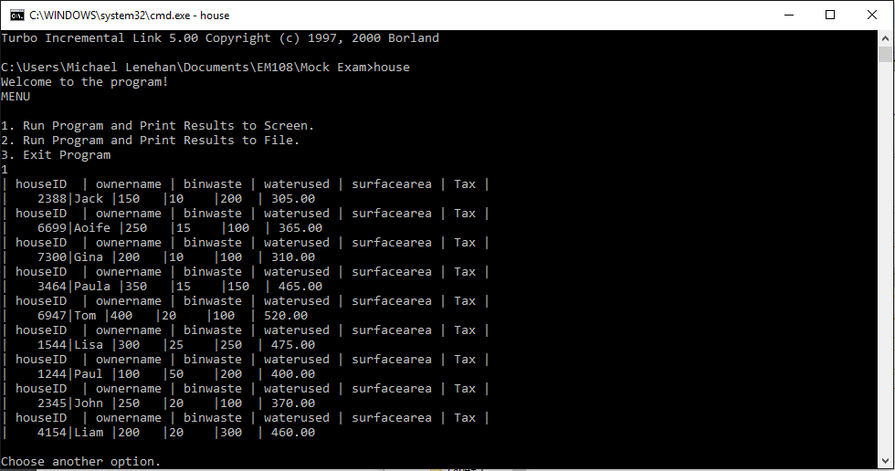
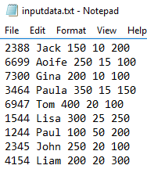
Correctly Printing table to file.

Better Format of Table
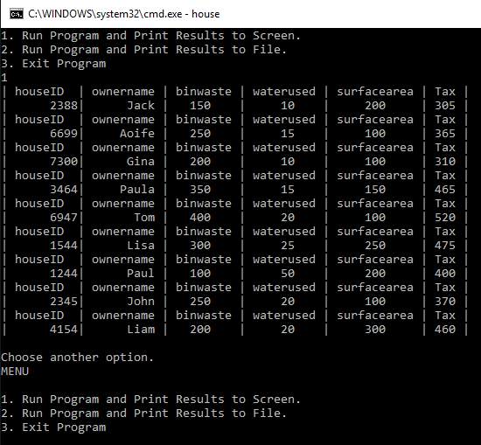

Other menu options working
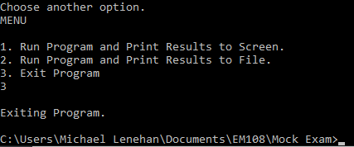
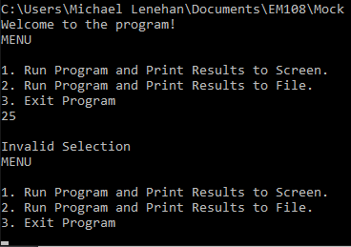
Menu default working

Code attached: Below is the Code used for the program.
#include <stdio.h>
#include <stdlib.h>
#include <string.h>

// Structured Type Definition

typedef struct house
{
char houseID[20];
char name[10];
int waste;
int water;
int area;
float tax;
} house_type;

// List of Functions

void print_menu(house_type house_info[],int norecs);
int read_records(FILE* fp, house_type house_info[]);
int compute_tax(house_type house_info[], int i);
void write_records(char* file_name, house_type house_info[], int i);
void print_results(house_type house_info[], int i);

//Main Function

int main()
{
house_type house_info[20];
int norecs;
int i;
FILE* fp;
FILE* results;

fp = fopen("inputdata.txt", "r");
results=fopen("results.txt","w");

printf("Welcome to the program!\n");
norecs = read_records(&*fp, house_info);
print_menu(house_info,norecs);
return(EXIT_SUCCESS);
}

//Function to Run a user menu

void print_menu(house_type house_info[],int norecs)
{
int i;
int selection;
while(selection != 3)
{
printf("MENU\n\n");
printf("1. Run Program and Print Results to Screen.\n2. Run Program and Print Results to File.\n3. Exit Program\n");
scanf("%d", &selection);

switch(selection)
{
case 1:
for(i=0;i<norecs;i++){
compute_tax(house_info,i);
//write_records("results.txt", house_info, i);
print_results(house_info,i);
}
printf("\nChoose another option.\n");
break;
case 2:
for(i=0;i<norecs;i++){
compute_tax(house_info,i);
write_records("results.txt", house_info, i);
//print_results(house_info,i);
}
printf("\nChoose another option.\n");
break;
case 3:
printf("\nExiting Program.\n");
break;

default:
printf("\nInvalid Selection\n");
break;
}
}
}

// Read records from file

int read_records(FILE* fp, house_type house_info[])
{
int norecs = 0;
char ch;

while(!feof(fp))
{
fscanf(fp, "%s%c%s%c%d%c%d%c%d ", house_info[norecs].houseID, &ch, house_info[norecs].name, &ch, &house_info[norecs].waste,&ch, &house_info[norecs].water, &ch, &house_info[norecs].area);
norecs=norecs+1;
}
fclose(fp);
return norecs;
}

// Compute Tax of each read in value

int compute_tax(house_type house_info[], int i)
{
if(house_info[i].area >= 200)
house_info[i].tax = ((house_info[i].area) + 0.5*(house_info[i].waste) + 3*(house_info[i].water));
else
house_info[i].tax = (100 + house_info[i].waste + house_info[i].water);
return house_info[i].tax;
}

// Write Records to file

void write_records(char* file_name, house_type house_info[], int i)
{
FILE* fp;
fp = fopen(file_name, "a");
fprintf(fp, "%s %s %d %d %d %1.0f\n", house_info[i].houseID, house_info[i].name, house_info[i].waste, house_info[i].water, house_info[i].area, house_info[i].tax);
fflush(fp);
fclose(fp);
}

// Print Results to the Screen

void print_results(house_type house_info[], int i)
{
printf("| houseID | ownername | binwaste | waterused | surfacearea | Tax |\n");
printf("|%10s|%10s | %d | %d | %d | %1.0f |\n", house_info[i].houseID, house_info[i].name, house_info[i].waste, house_info[i].water,house_info[i].area, house_info[i].tax);
}

